TP CSS

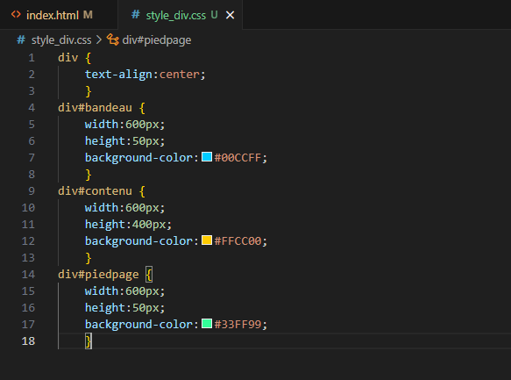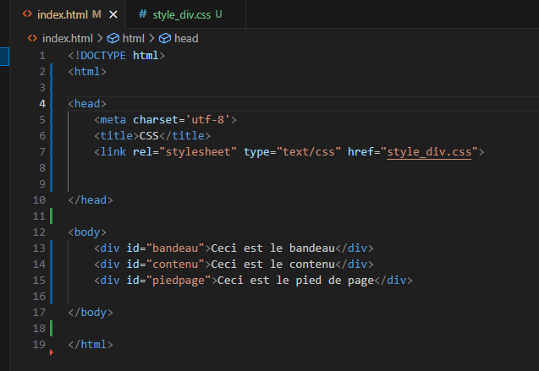**EXO 1 :**

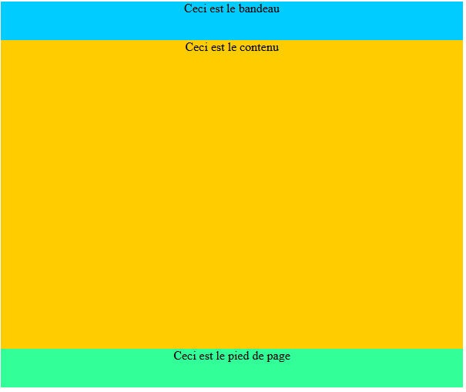**Résultat :**

**EXO 2 :**

**Résultat :**

**EXO 3 :**

**Résultat :**

**EXO 4 :**

**Résultat :**

**EXO 5 :**

**Résultat :**

**EXO 6 :**

**Résultat :**

